

# “IMDB Movie”

Group 3

Names : Ahmad Rifai

Muhammad Faqih Al Fadholi

Class : 4SE3

Faculty : Mr. Reza Maulana, S.Kom., M.Kom

# CEP CCIT

**FAKULTAS TEKNIK UNIVERSITAS INDONESIA 2025**

**PROJECT ON**

*IMDB Movie*



**Developed by**

**Ahmad Rifai**

**Muhammad Faqih Al Fadholi**

**IMDB Movie**

Batch Code Start Date

End Date

: 4SE3

: 13 March 2025

: 25 March 2025

Name of Faculty : Mr. Reza Maulana, S.Kom., M.Kom

Names of Developer :

Ahmad Rifai

Muhammad Faqih Al Fadholi

Date of Submission: 25 March 2025



**CERTIFICATE**

This is to certify that this report titled “IMDB Moviel” embodies the original work done by Ahmad Rifai and Muhammad Faqih Al FAdholi Project in partial fulfillment of their course requirement at NIIT.

Coordinator:

Mr. Reza Maulana, S.Kom., M.Kom

**ACKNOWLEDGEMENT**

Assalamu'alaikum warahmatullahi wabarakatuh

All praise be to Allah SWT for all His grace, so that we can complete this paper entitled “IMDB Movie” in accordance with the specified time. Without the blessing and grace of Allah SWT, it is impossible for this paper to be completed properly and on time. The author would like to thank all those who have supported and helped, especially to our supervisor Reza Maulana, S.kom., M.kom.

The author realizes that the writing of this paper is far from perfect, therefore the author really hopes for the participation of readers to provide input in the form of criticism and suggestions so that this paper becomes better in terms of information. The author apologizes profusely if there are things that are less pleasing in writing this paper. Finally, the author would like to thank you and happy reading, Wassalamu'alaikum warahmatullahi wabarakatuh.

Depok, March 13, 2025

**SYSTEM ANALYSIS**

**System Summary**:

This project focuses on designing the IMDb Movie website, which aims to provide an optimal user experience in browsing film and television show information. In response to technological developments and existing trends, the IMDb Movie website was designed to be responsive, ensuring easy accessibility across various devices.

The website features an intuitive interface for exploring various film options, including synopsis, as well as reviews. Moreover, IMDb Movie is committed to providing a pleasant experience for film enthusiasts by providing efficient search features and a transparent rating system.

**SYSTEM ANALYSIS**

## Layout:

* 1. Home page
     + Navbar
     + Logo
     + Banner
     + Content
     + Footer

## Responses:

* Navbar: Changes to stacked menu in (575 px)
* Picture Card: Stacks by one card below (611 px), Two cards above (611 px), three cards in (912 px)
* Bottom Content: Stacks sideways at above (780 px) starts moving downwards below (519 px)

\

sssssssssss

**TECHNOLOGY USED**

**Visual Studio Code**

Visual Studio Code (VSCode) is a robust, free, and open-source code editor developed by Microsoft. It supports multiple programming languages, offering features like IntelliSense for smart completions, debugging support, and built-in Git commands. Its intuitive interface makes it a preferred choice for programmers worldwide.

**HTML**

HTML is the standard markup language used to structure content on the web. It allows developers to organize elements such as paragraphs, images, links, and forms on a webpage. HTML forms the backbone of any modern website, working alongside CSS and JavaScript to provide layout and functionality.

**CSS**

CSS is a style sheet language used to control the presentation of a web page. It defines how HTML elements should appear, such as their layout, colors, fonts, and spacing. CSS allows web developers to create visually appealing and responsive designs that adapt to different screen sizes and devices.

**Bootstrap**

Bootstrap is an open-source front-end framework that enables developers to build responsive, mobile-first web pages quickly. It includes a collection of pre-designed components, such as navigation bars, modals, buttons, and grids, that are easily customizable. Bootstrap helps ensure consistent design and layout across different browsers and devices, making web development faster and more efficient.

**JavaScript (for API calls with async fetch)**

JavaScript is a versatile programming language that enables interactive features on webpages. It allows developers to dynamically update content, handle user input, and interact with external APIs. To fetch data from the TMDb API asynchronously, JavaScript's fetch() function is used. The async keyword ensures that the call does not block other code execution, allowing smooth loading of movie data without freezing the user interface.

**CONFIGURATION**

**Hardware**: Acer Swift go 14 **Operating System:** Windows 11 Home **Software:** Visual Studio Code

\

sssssssssss

**PROJECT FILE DETAILS**

|  |  |  |
| --- | --- | --- |
| **S.No** | **File Name** | **Remarks** |
| 1 | IMDB Movie.docx | Research Paper |
| 2 | IMDB Movie.pptx | Power Point |

\

sssssssssss

**RESPONSE COMPARISON**

**Navbar**

Laptop

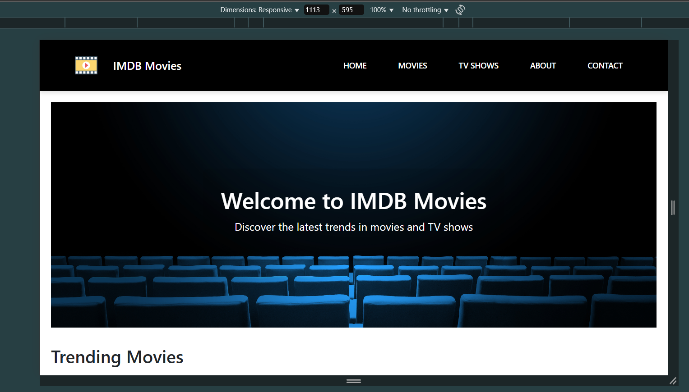

Tablet

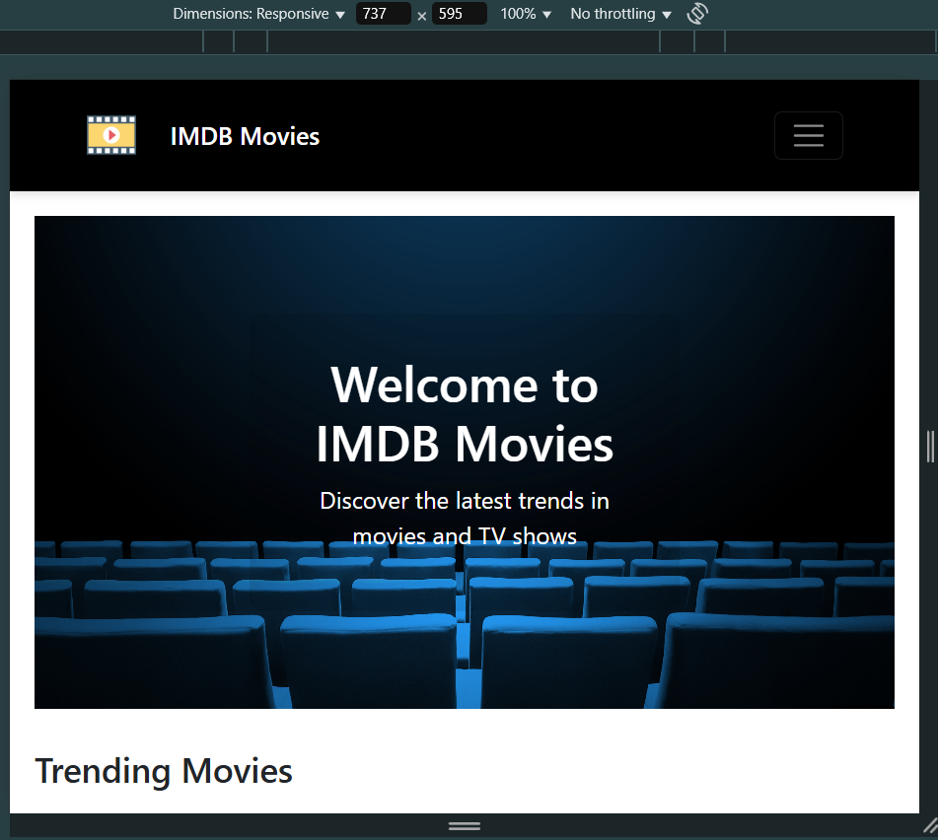

# RESPONSE COMPARISON

**Navbar**

HP

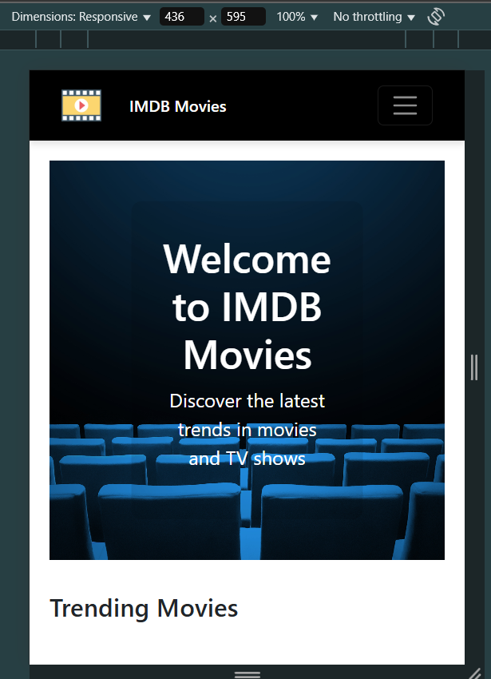

\

sssssssssss

**RESPONSE COMPARISON**

**Middle Content**

Laptop

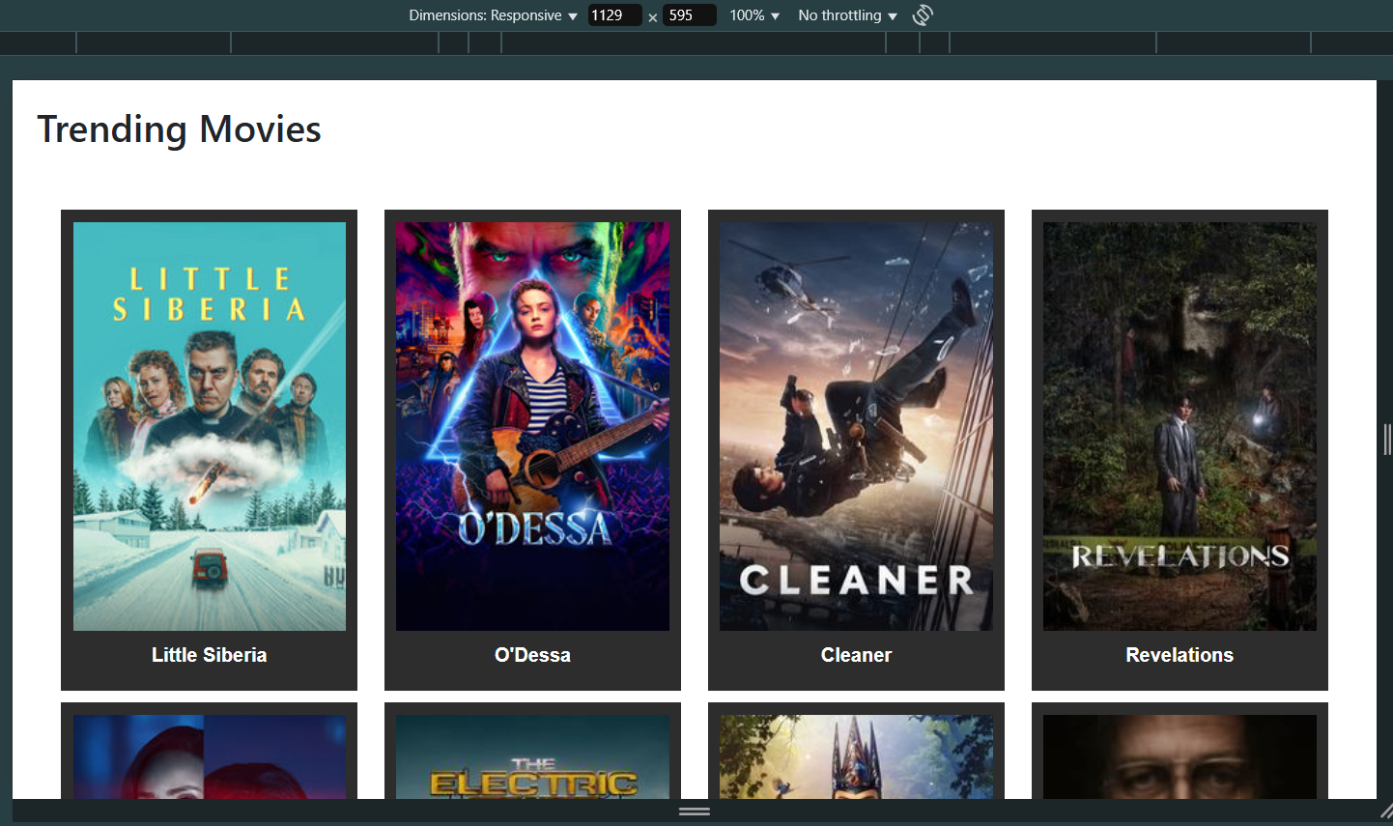

Tablet

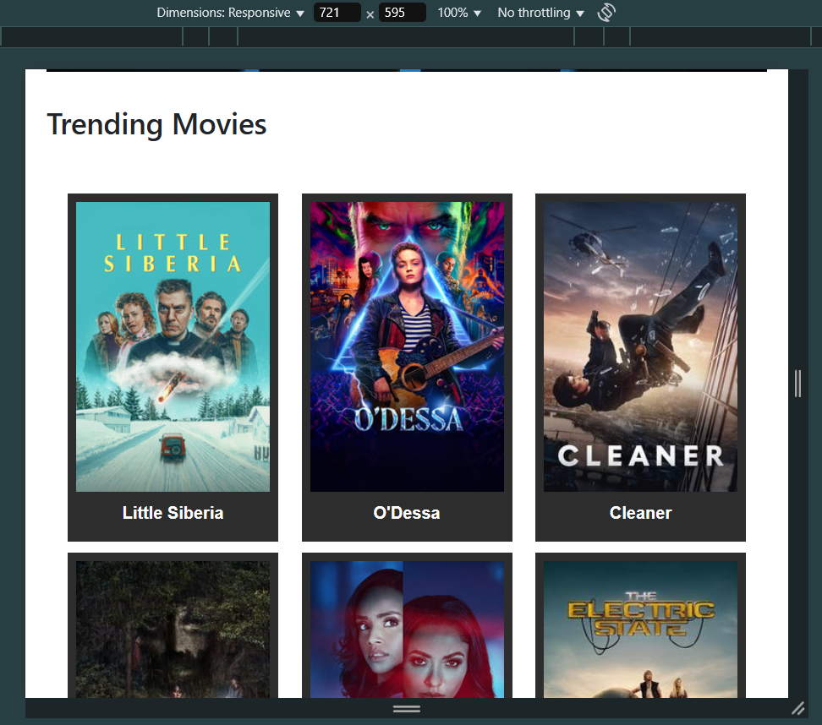

\

sssssssssss

**RESPONSE COMPARISON**

**Middle Content**

HP

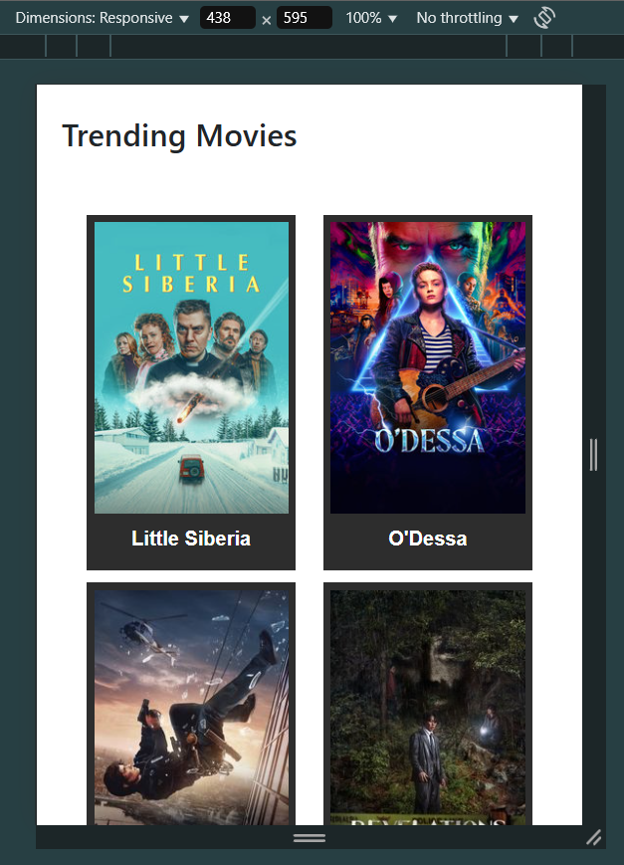

\

sssssssssss

**RESPONSE COMPARISON**

**Bottom content**

Laptop

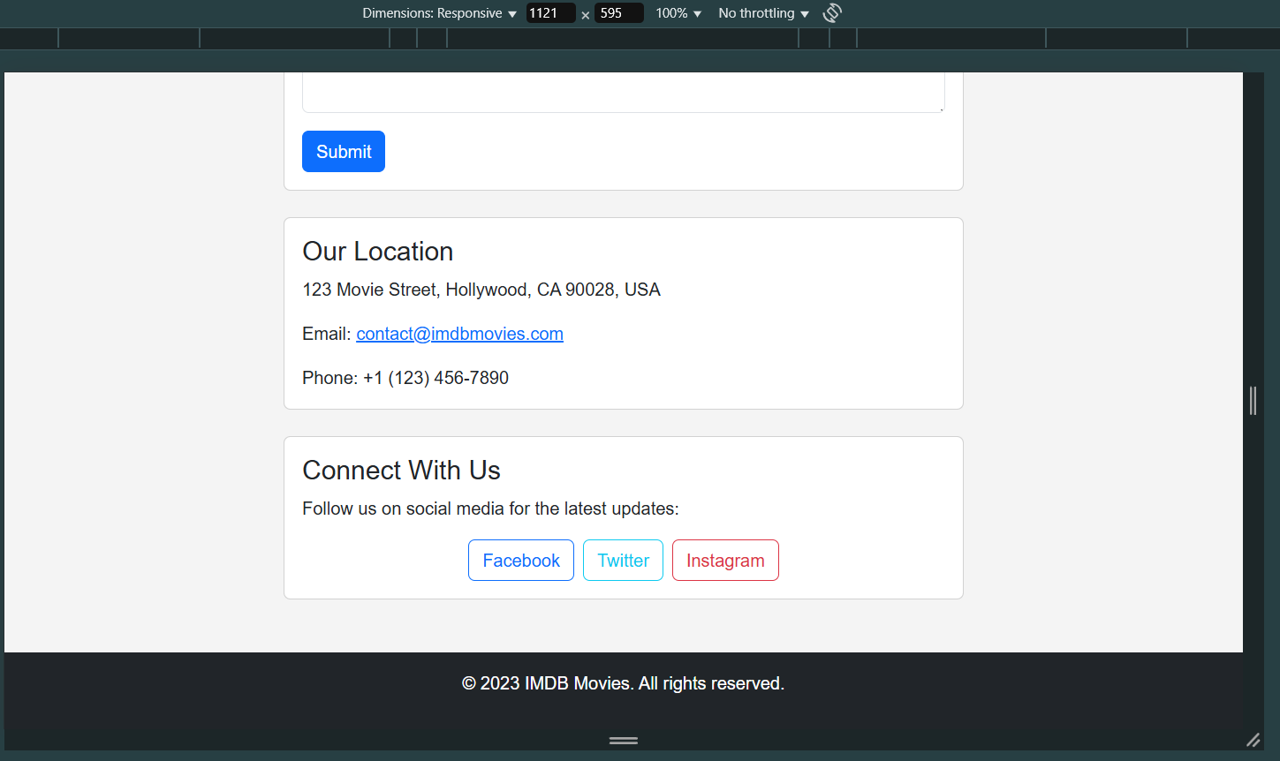

Tablet

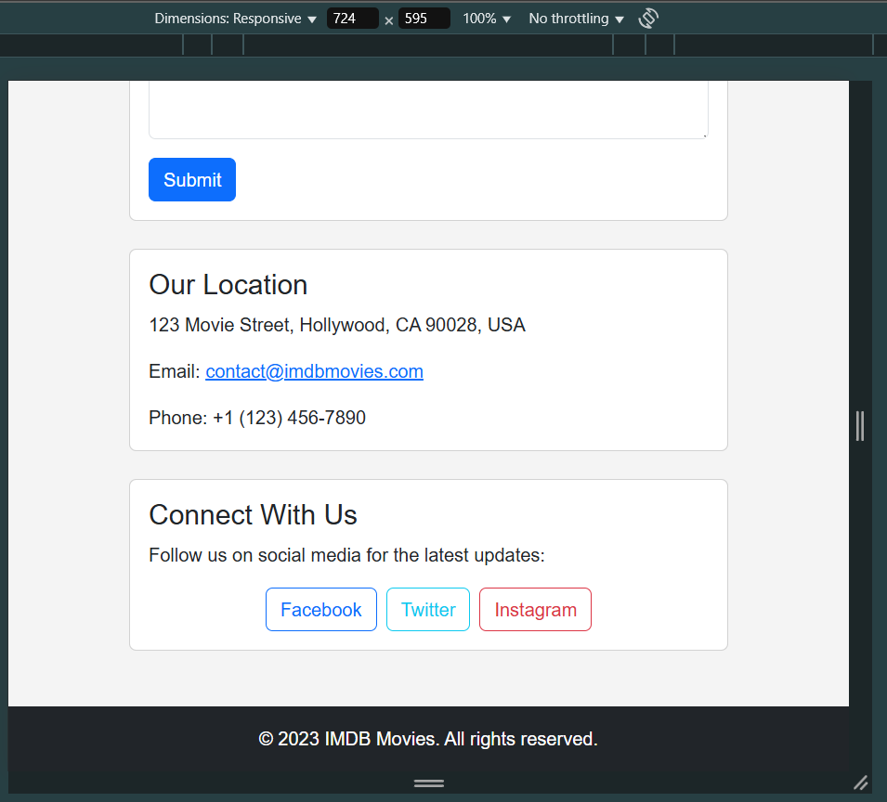

**RESPONSE COMPARISON**

**Bottom content**

HP

